**CSS (Positions, Z-index)**

**Duration 4h (Totally 8)**

**Basic**

**1.Add 3 div contain the following:**

**a)Div1 position=Relative**

**b)Div2 position=fixed & z-index**

**c)Div3 position=absolute**

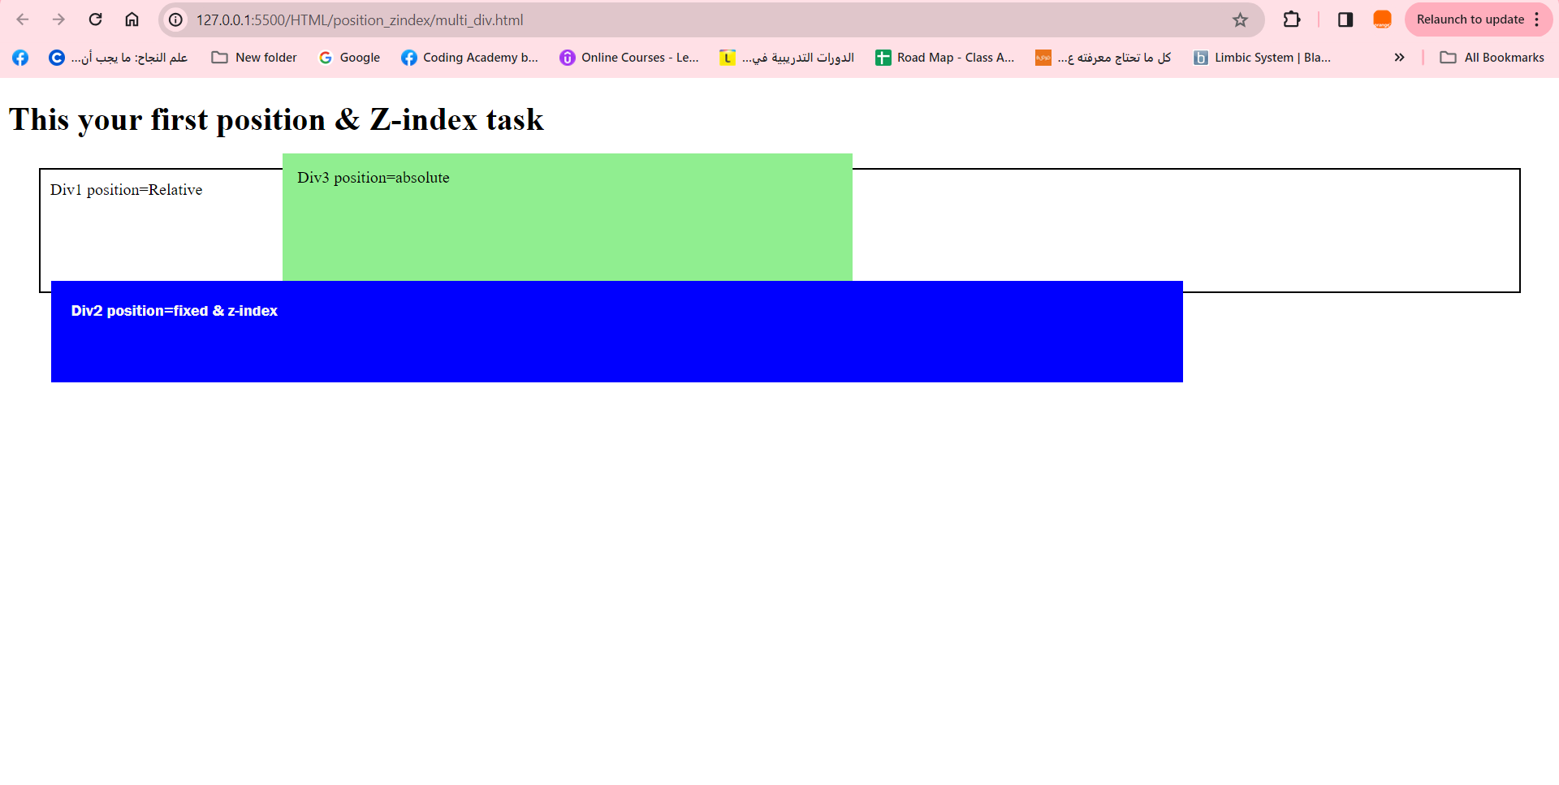

**2.Z-index, position (absolute):**

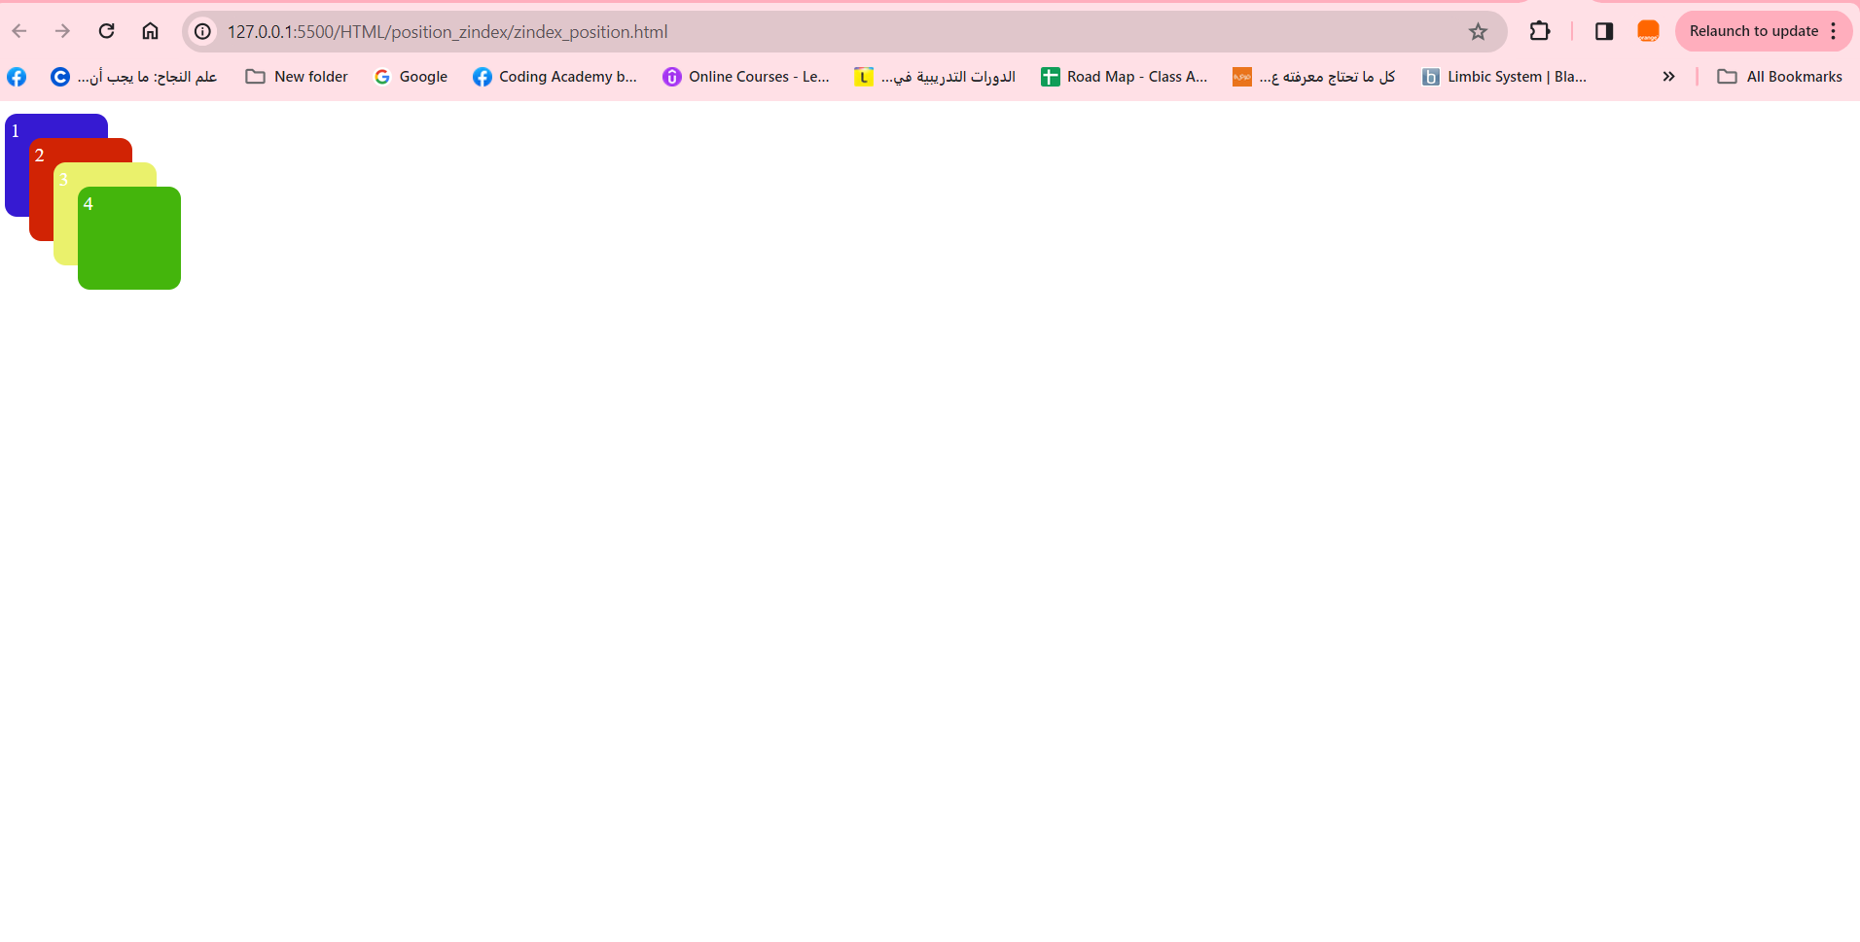

**3.Position absolute:**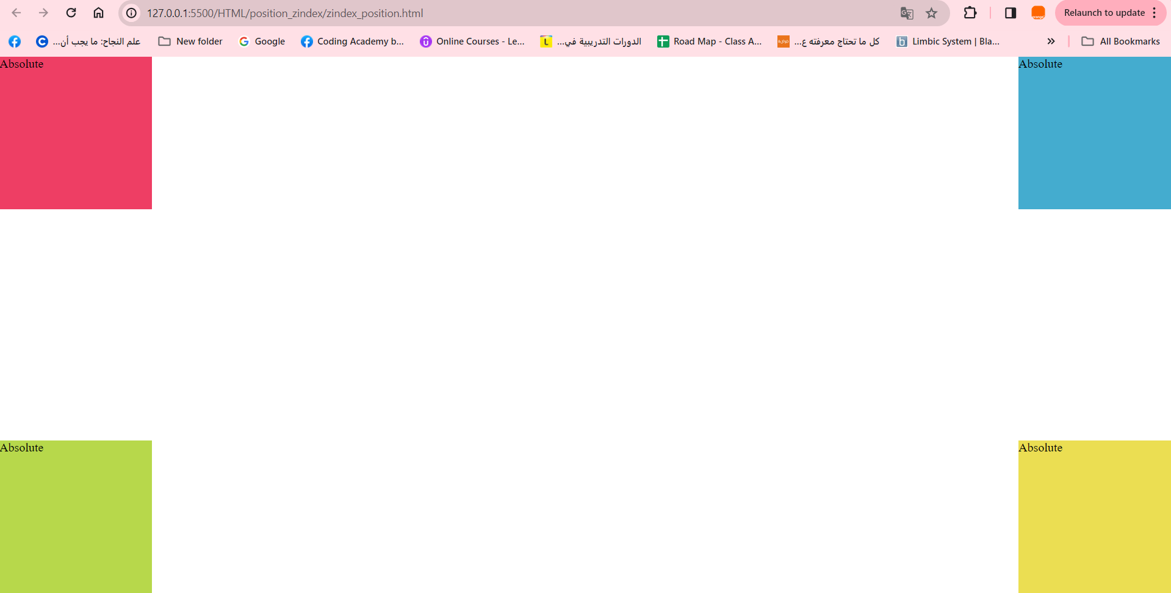

**Intermediate**

**4.Position relative & static:**

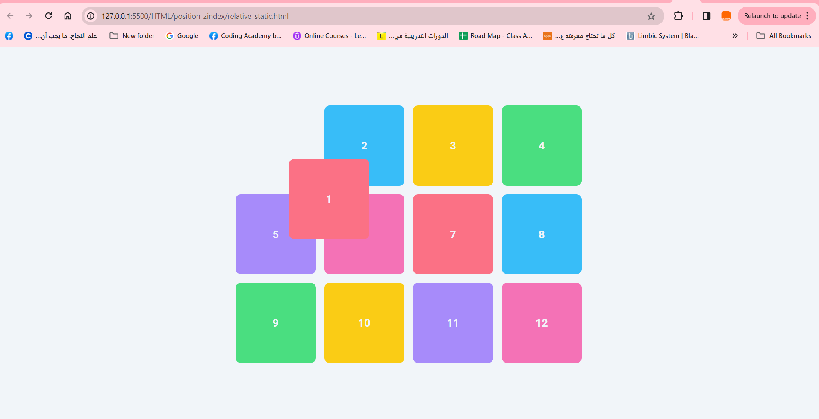

**5.Create the following:**

**a) Add image to left side of the page.**

**b) use position=”fixed” it will not disappear when scroll down in web page.**

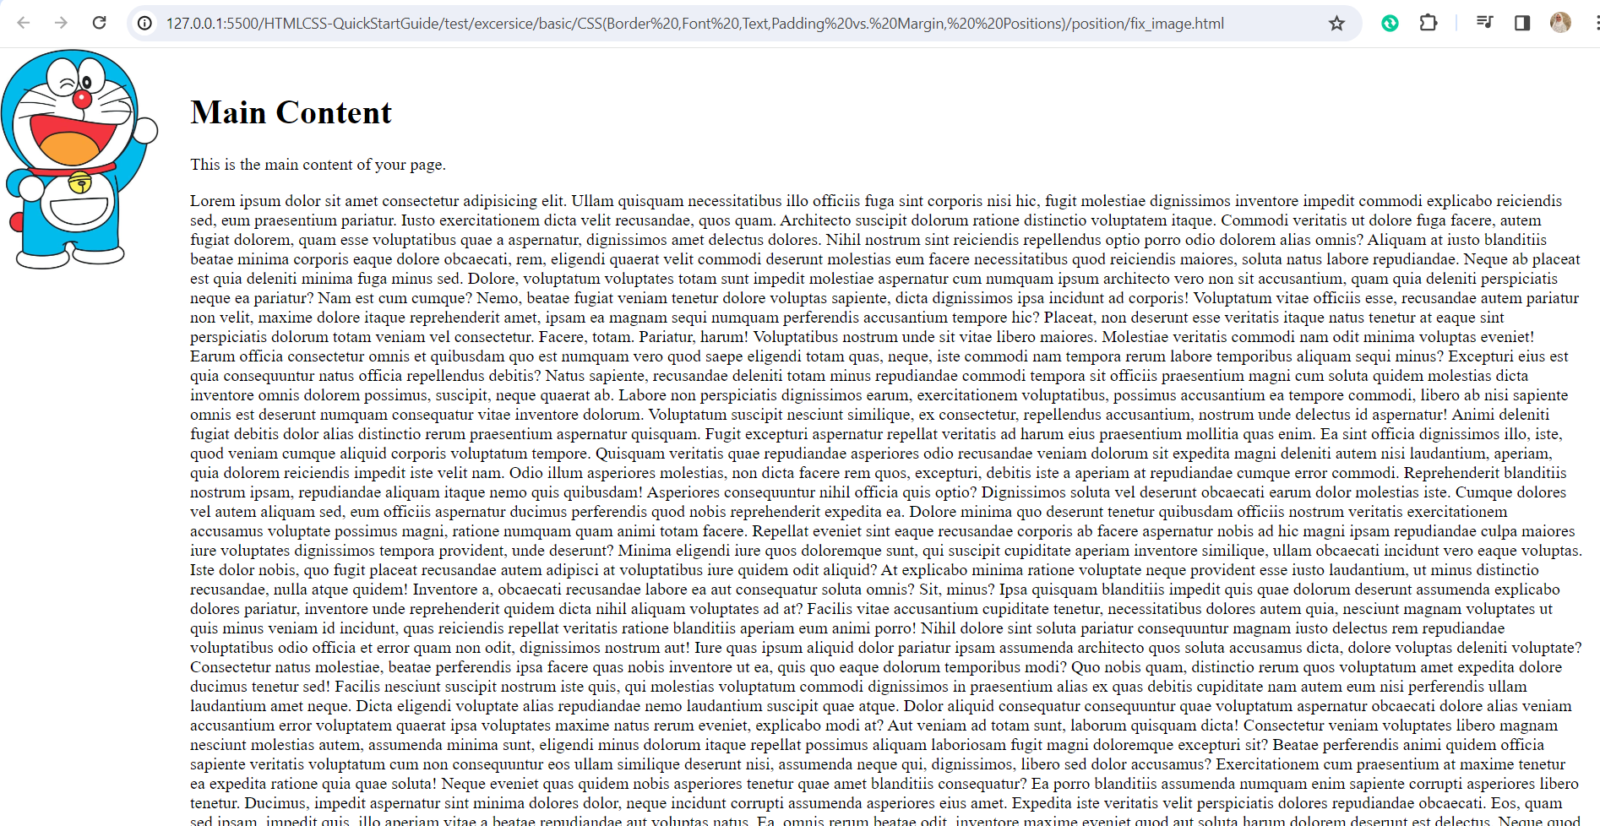

**6.Use position: sticky:**

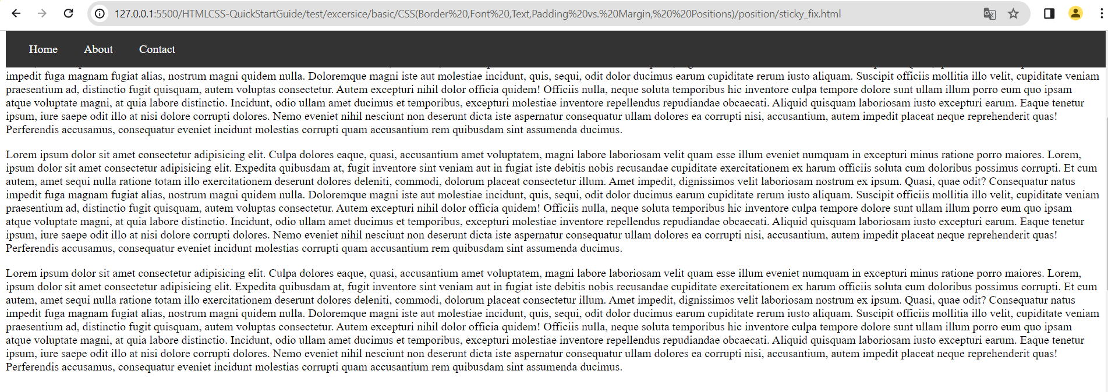

**7.Add 4 image position absolute and z-index for first image:**

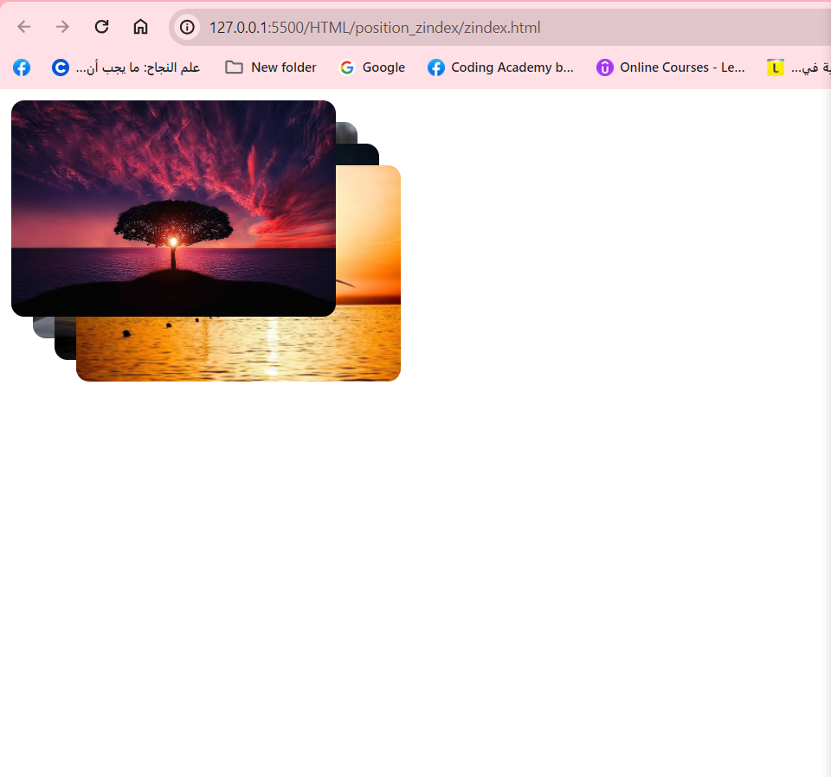

**Advanced**

**8.The following video show basic website we used position prosperity:**

[**https://drive.google.com/file/d/18PZruIJR70ZG9upDn2QmXCcEdbQ_dArx/view?usp=sharing**](https://drive.google.com/file/d/18PZruIJR70ZG9upDn2QmXCcEdbQ_dArx/view?usp=sharing)